
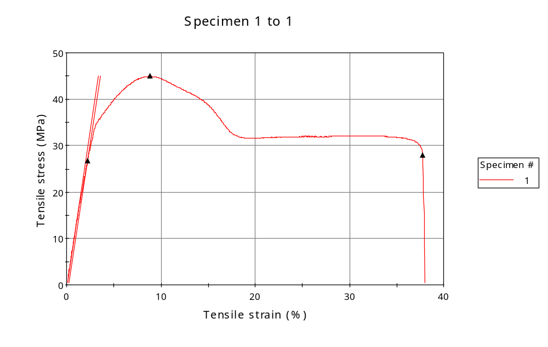
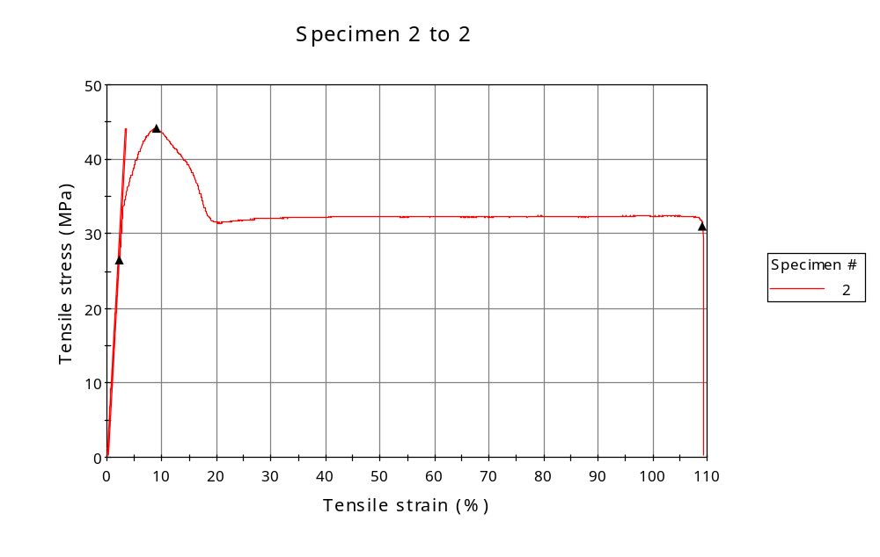
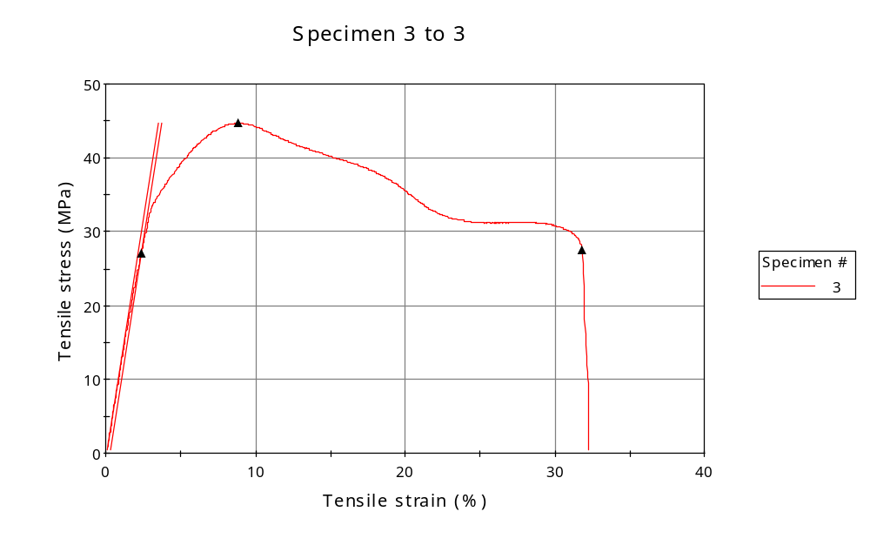
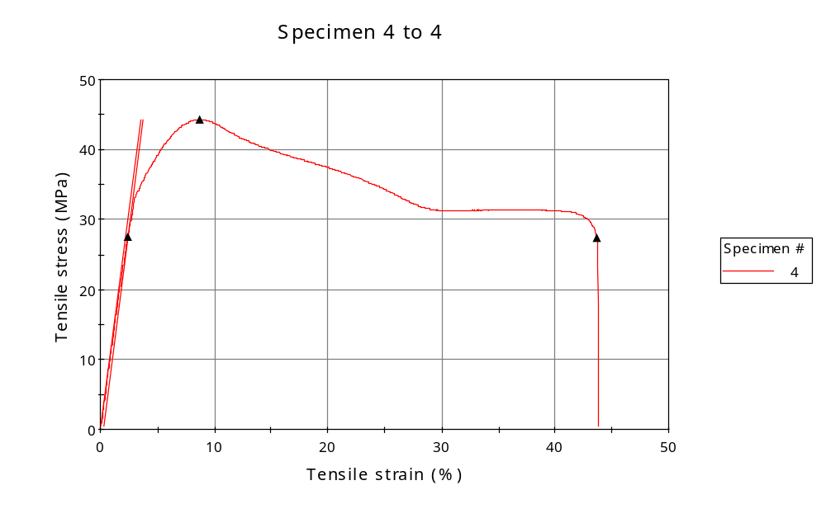
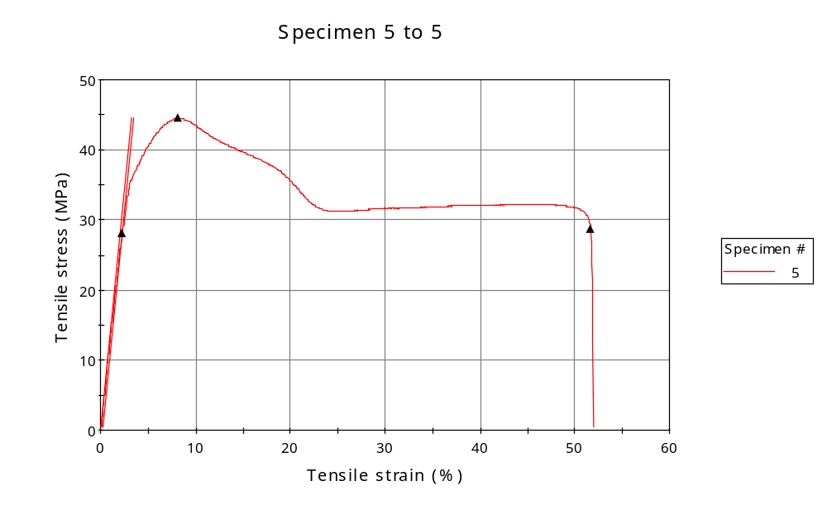
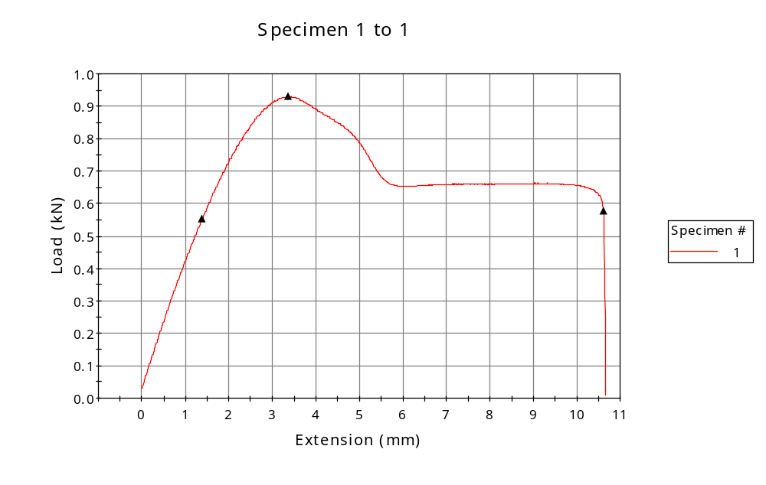
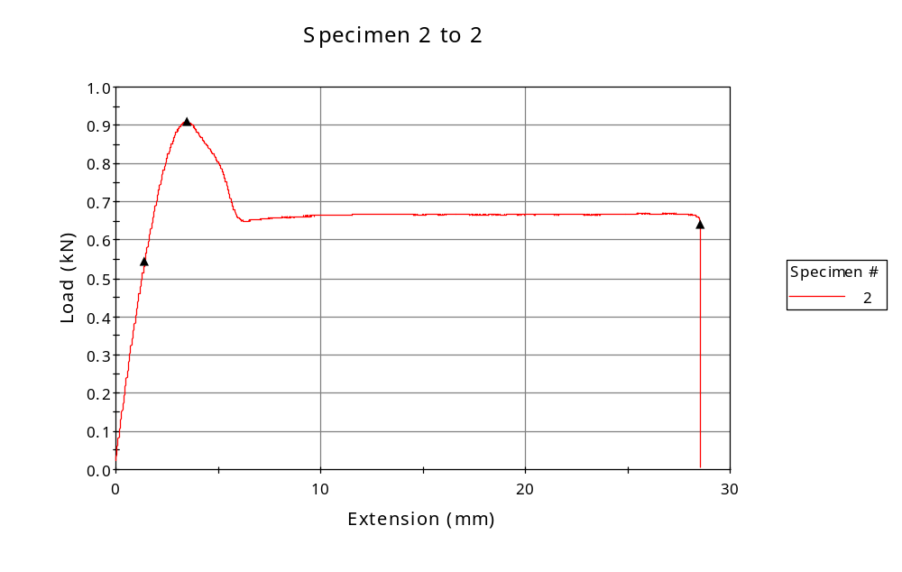
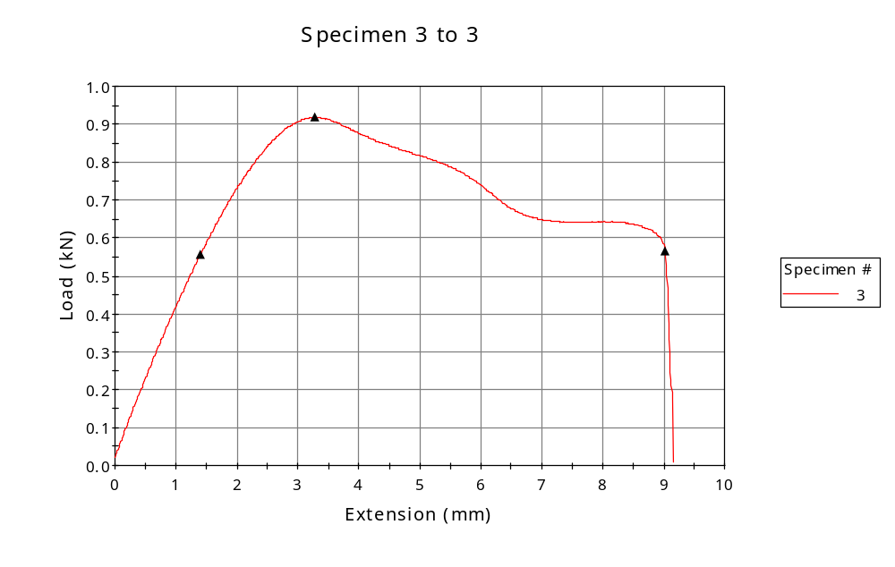
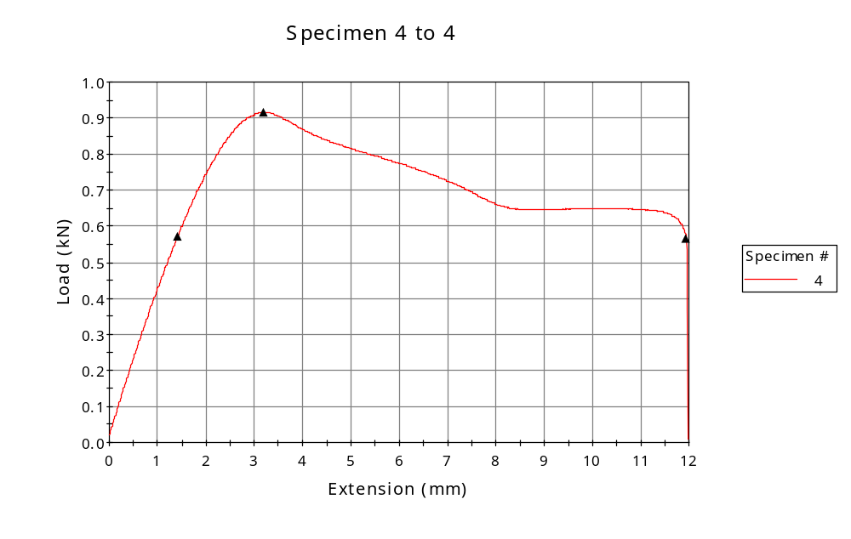
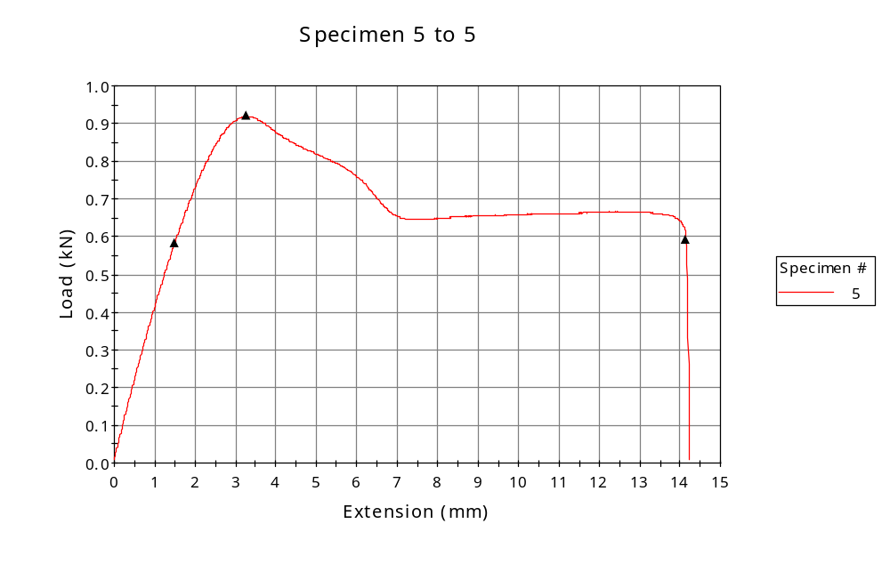

 | CP ID | Length  (mm) | Width  (mm) | Thickness  (mm) | Modulus (Automatic Young's)  (MPa)
1 | CP-FDM_XZ3_01 | 25.00 | 6.19 | 3.34 | 1337
2 | CP-FDM_XZ3_02 | 25.00 | 6.18 | 3.34 | 1327
3 | CP-FDM_XZ3_03 | 25.00 | 6.19 | 3.32 | 1288
4 | CP-FDM_XZ3_04 | 25.00 | 6.17 | 3.35 | 1258
5 | CP-FDM_XZ3_05 | 25.00 | 6.21 | 3.33 | 1365
Maximum |  | 25.00 | 6.21 | 3.35 | 1365
Minimum |  | 25.00 | 6.17 | 3.32 | 1258

 | Load at Fy ( 0.2 %) - LE  (kN) | Tensao em Fy ( 0.2 %) - LE  (MPa) | Deformacao em Fy ( 0.2 %) - LE  (%) | Forca Max  (kN) | Tensao na Forca Max - LR  (MPa)
1 | 0.553 | 27 | 2.210 | 0.930 | 45
2 | 0.544 | 26 | 2.193 | 0.910 | 44
3 | 0.555 | 27 | 2.343 | 0.918 | 45
4 | 0.570 | 28 | 2.399 | 0.916 | 44
5 | 0.582 | 28 | 2.286 | 0.920 | 44
Maximum | 0.582 | 28 | 2.399 | 0.930 | 45
Minimum | 0.544 | 26 | 2.193 | 0.910 | 44

 | Deformacao na Forca Max - LR  (%) | Forca na Forca na Quebra - LQ  (kN) | Deformacao na Forca na Quebra - LQ  (%) | Final length  (mm) | Final width  (mm)
1 | 8.814 | 0.578 | 37.748 | 119.00 | 6.82
2 | 9.024 | 0.640 | 109.257 | 119.00 | 6.82
3 | 8.871 | 0.564 | 31.804 | 119.00 | 6.82
4 | 8.702 | 0.566 | 43.636 | 119.00 | 6.82
5 | 8.104 | 0.593 | 51.637 | 119.00 | 6.82
Maximum | 9.024 | 0.640 | 109.257 | 119.00 | 6.82
Minimum | 8.104 | 0.564 | 31.804 | 119.00 | 6.82

 | Alongamento
1 | 3.76
2 | 3.76
3 | 3.76
4 | 3.76
5 | 3.76
Maximum | 3.76
Minimum | 3.76

